Baza de date pentru Netflix

Tema 5

Mincu Adrian-Lucian

grupa 232

Cuprins

Contents

Diagrama conceptuală 3

Exercițiul 10 4

Cerinta 4

Cursor Clasic 4

Ciclu Cursor 5

Ciclu Cursor Cu Subcereri 6

Expresii Cursor 7

# 

# Diagrama conceptuală

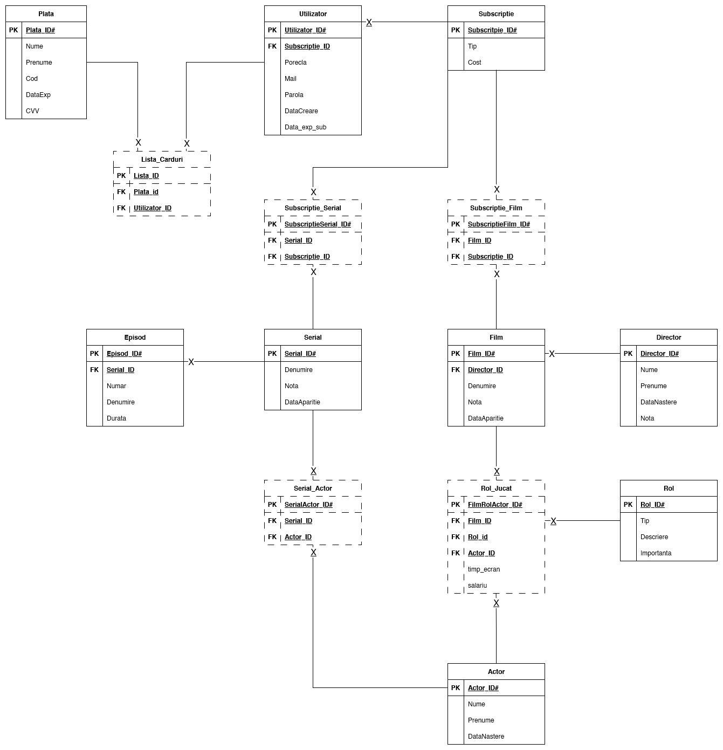

# Exercițiul 10

## Cerinta

Pentru fiecare Serial cu id-ul in lista = (1,3,6) afisati numele tuturor episoadelor ce apartin serialelor respective

## Cursor Clasic

declare  
 v_id_ser SERIAL.serial_id%type;  
 v_nume_ser SERIAL.denumire%type;  
 v_nume_episod varchar2(50);  
 v_areEpisod number(1) := 0;  
  
 CURSOR seriale IS  
 select SERIAL_ID, DENUMIRE  
 from SERIAL  
 WHERE SERIAL_ID IN (1,3,6);  
  
 CURSOR episod(id number) IS  
 select DENUMIRE  
 from EPISOD  
 where SERIAL_ID = id;  
begin  
 OPEN seriale;  
 loop  
 Fetch seriale into v_id_ser, v_nume_ser;  
 exit when seriale%notfound;  
  
 v_areEpisod := 0;  
 DBMS_OUTPUT.*PUT_LINE*('Serialul: ' || v_nume_ser);  
 OPEN episod(v_id_ser);  
 loop  
 Fetch episod into v_nume_episod;  
 exit when EPISOD%notfound;  
 v_areEpisod := 1;  
 DBMS_OUTPUT.*PUT_LINE*(' ' || v_nume_episod);  
 end loop;  
 close episod;  
 if v_areEpisod = 0 then DBMS_OUTPUT.*PUT_LINE*(' Nu are episoade');  
 end if;  
 end loop;  
 close seriale;  
end;  
/

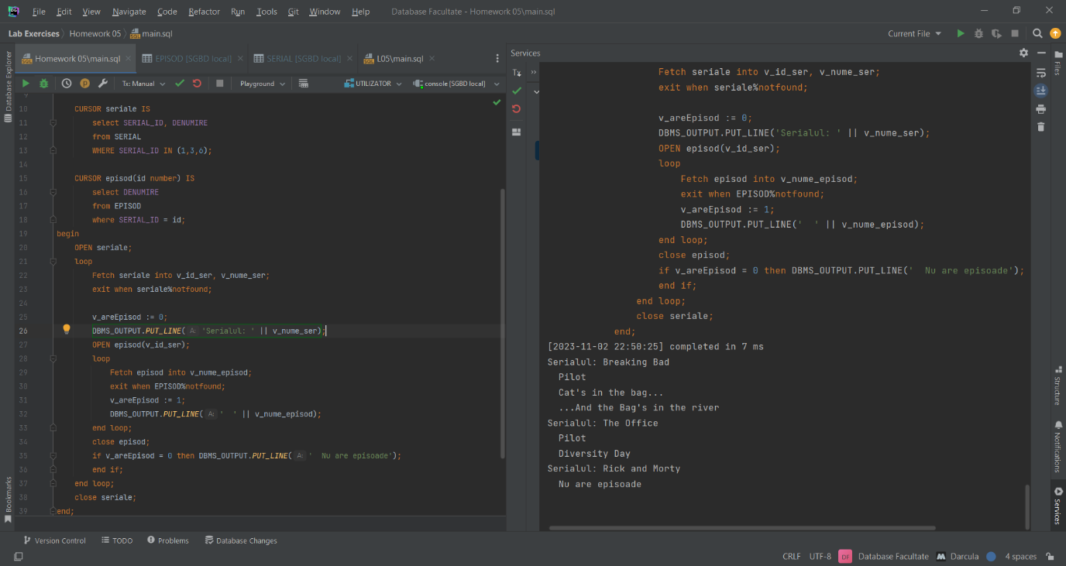

## Ciclu Cursor

declare  
 v_areEpisod number(1) := 0;  
  
 CURSOR seriale IS  
 select SERIAL_ID, DENUMIRE  
 from SERIAL  
 WHERE SERIAL_ID IN (1,3,6);  
  
 CURSOR episod(id number) IS  
 select DENUMIRE  
 from EPISOD  
 where SERIAL_ID = id;  
begin  
 for serial in seriale loop  
 v_areEpisod := 0;  
 DBMS_OUTPUT.*PUT_LINE*('Serialul: ' || serial.DENUMIRE);  
 for ep in episod(serial.SERIAL_ID) loop  
 v_areEpisod := 1;  
 DBMS_OUTPUT.*PUT_LINE*(' ' || ep.denumire);  
 end loop;  
 if v_areEpisod = 0 then DBMS_OUTPUT.*PUT_LINE*(' Nu are episoade');  
 end if;  
 end loop;  
end;  
/

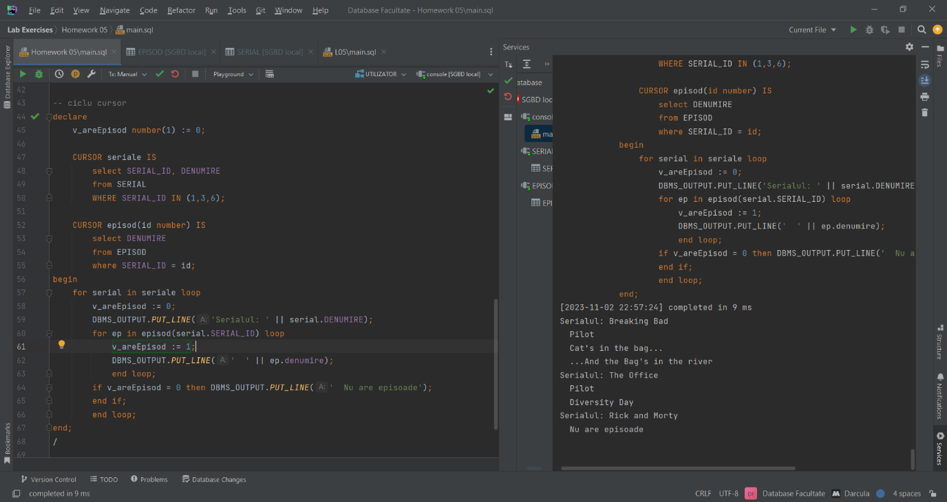

## Ciclu Cursor Cu Subcereri

declare  
 v_areEpisod number(1) := 0;  
begin  
 for serial in (select SERIAL_ID, DENUMIRE  
 from SERIAL  
 WHERE SERIAL_ID IN (1, 3, 6))  
 loop  
 v_areEpisod := 0;  
 DBMS_OUTPUT.*PUT_LINE*('Serialul: ' || serial.DENUMIRE);  
 for ep in (select DENUMIRE  
 from EPISOD  
 where SERIAL_ID = serial.SERIAL_ID)  
 loop  
 v_areEpisod := 1;  
 DBMS_OUTPUT.*PUT_LINE*(' ' || ep.denumire);  
 end loop;  
 if v_areEpisod = 0 then DBMS_OUTPUT.*PUT_LINE*(' Nu are episoade');  
 end if;  
 end loop;  
end;

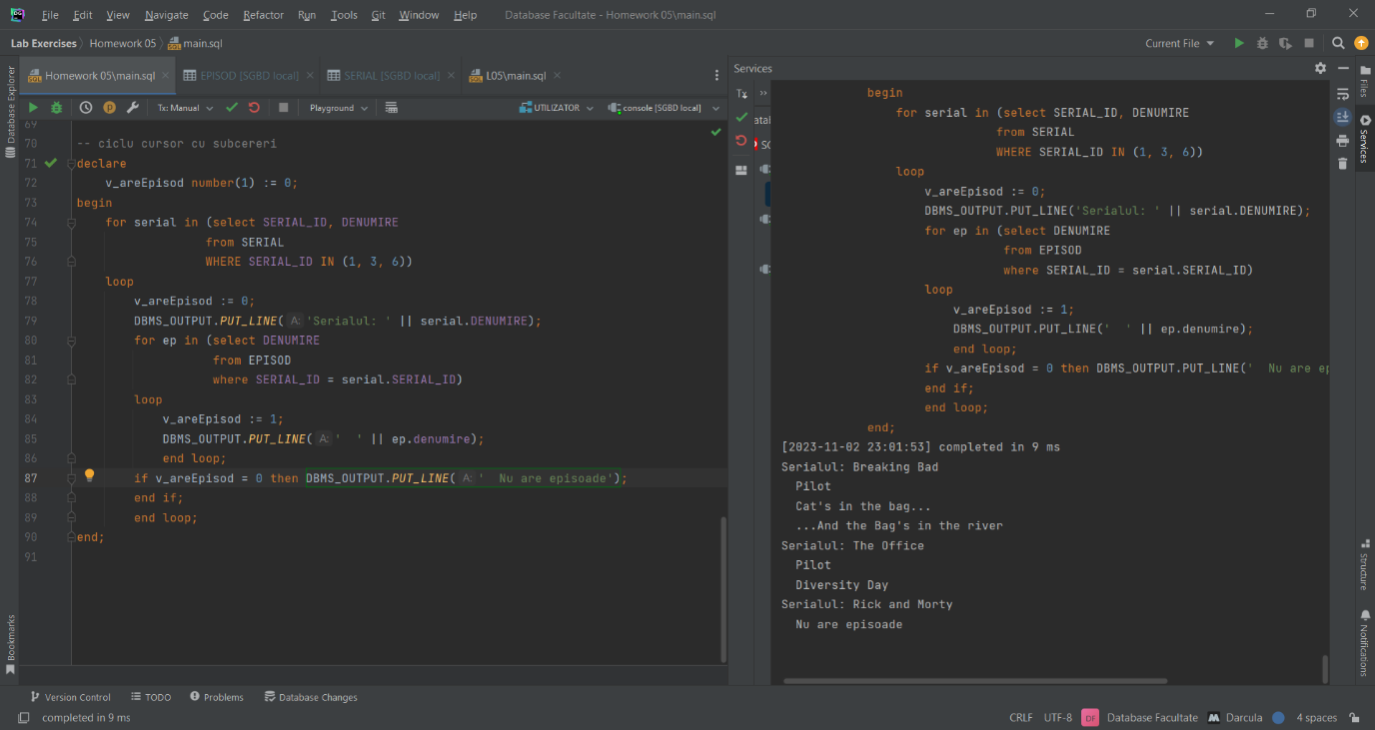

## Expresii Cursor

declare  
 TYPE refcursor is REF CURSOR;  
 CURSOR seriale IS  
 select DENUMIRE,  
 CURSOR (select DENUMIRE  
 from EPISOD  
 where SERIAL_ID = serial.SERIAL_ID)  
 from SERIAL  
 where SERIAL_ID in (1,3,6);  
 v_nume_serial SERIAL.denumire%type;  
 v_nume_ep EPISOD.denumire%type;  
 v_cursor refcursor;  
 v_areEpisod number(1) := 0;  
begin  
 open seriale;  
 loop  
 fetch seriale into v_nume_serial, v_cursor;  
 exit when seriale%notfound;  
 v_areEpisod := 0;  
 DBMS_OUTPUT.*PUT_LINE*('Serialul: ' || v_nume_serial);  
  
 loop  
 fetch v_cursor into v_nume_ep;  
 exit when v_cursor%notfound;  
 v_areEpisod := 1;  
 DBMS_OUTPUT.*PUT_LINE*(' ' || v_nume_ep);  
 end loop;  
  
 if v_areEpisod = 0 then DBMS_OUTPUT.*PUT_LINE*(' Nu are episoade');  
 end if;  
 end loop;  
end;  
/

